Smart Factory and intelligent controls

Project – Bi-Directional visitor counter

- Student name – Shrey Parmar Student id – 9917605091

Table of Contents
Introduction 3
Problem Statement 4
System Implementation 5
Components: - 5
1.NodeMCU ESP8266 5
2.IR Sensors 7
3.SG90 Servo motor 8
Schematic 9
Working Model 10
Flow Chart: - 12
Communication System 13
Web Dashboard of Blynk IOT: 13
Existing product on internet which can be uses in real-time. 15
System specification – 15
Conclusion 17

Introduction
- Increasing in human population and current pandemic situation demands the smart bidirectional visitor counter with automatic door closing system. Advanced technology systems called bi-directional visitor counters are made to precisely monitor the flow of people and cars into and out of a designated space, like a parking lot, retail store, event space, or hub for public transportation. These counters enable businesses, organizations, and authorities to manage crowd flow, optimize resource allocation, monitor occupancy levels, and improve overall operational efficiency by providing real-time data on the movement of people or vehicles in both directions.

- In addition to optimizing operational efficiency and resource allocation, bi-directional visitor counters also play a crucial role in enhancing safety and security. By providing real-time visibility into crowd flow and occupancy levels, these systems enable authorities to effectively manage crowd control, respond to emergencies, and ensure the safety of individuals within the monitored area.

- Bi-directional visitor counters can distinguish between entries and exits, precisely count each movement, and provide comprehensive insights into visitor or vehicle flow patterns by combining sensors, cameras, and data processing algorithms. Decision-making processes benefit greatly from this data, which helps companies make well-informed choices about hiring, using available space, developing marketing plans, and customer care programs.

- All things considered, bi-directional visitor counters are crucial tools for companies, associations, and towns looking to enhance client experiences, guarantee legal compliance, and make data-driven choices in today's fast-paced and dynamic settings. These counters give stakeholders the ability to efficiently manage their operations and adjust to shifting demands and conditions by precisely tracking the movements of visitors or vehicles in real-time.

Problem Statement
- In today’s fast-growing world, it is very necessary to manage number of people in various public places to properly manage the available resources and for better security.

- In the pandemic situation it is not feasible to count the number of people in the public places. Count changes rapidly as number of people enters and leaves the places continuously. Pandemic also gives a limitation that overcrowding is not possible in public places. This needs a person to monitor the crowd.

- We have been seen these many times as we need to count the number of cars in parking area because there are some limited spaces for car parking at that time, we require something that continuously count the number of vehicles in parking area.

- During the big sales seasons it is mandatory for shop or mall owners to give attention and provide proper customer service to each individual and if there are huge number of people have entered compare to the number of customer service representative then there will be lot of chaos which wouldn’t handle by shop employees and that time it is necessary to have some specific amount of people in shop.

- Mall and big shop owners require kind of software that indicates them the amount of traffic has been visiting their places in a single day.

- It is essential for business and organizations to provide resources they get to know that by getting information real-time data on visitor and vehicle flow

- In retail environment, event venues and public places, the real time data on visitor and vehicle is used for accurate flow of customer and provide equal time to everyone and to ensure the safety and security of individual.

System Implementation
We have decided to make a visitor counter that will automatically count the number of people in particular area which includes two IR sensors one to count the number of people entering the area and one to count number of people exiting the area.
Total number of people in the place at a time can be found easily by subtraction of the count values by the IR sensors. If number a people exceed the particular number an alarm will rang.

Components: -

1.NodeMCU ESP8266
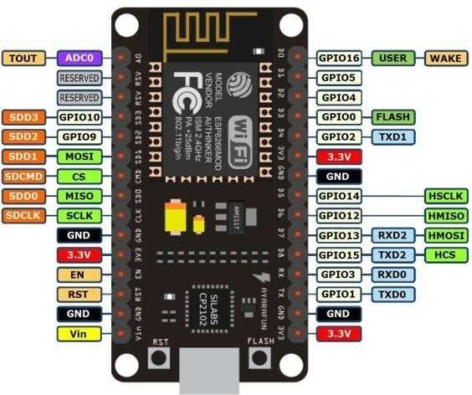
The NodeMCU (Node MicroController Unit) is an open-source software and hardware development environment built around an inexpensive System-on-a-Chip (SoC) called theESP8266. The ESP8266, designed and manufactured by Espressif Systems, contains the crucial elements of a computer: CPU, RAM, networking (WiFi), and even a modern operating system and SDK. That makes it an excellent choice for Internet of Things (IoT) projects of all kinds.

Nodemcu ESP8266 Specifications
- Microcontroller: Tensilica 32-bit RISC CPU Xtensa LX106
- Operating Voltage: 3.3V
- Input Voltage: 7-12V
- Digital I/O Pins (DIO): 16 Analog Input Pins (ADC): 1
- UARTs: 1
- SPIs: 1

- I2Cs: 1

- Flash Memory: 4 MB SRAM: 64 KB
- Clock Speed: 80 MHz

- USB-TTL based on CP2102 is included onboard, Enabling Plug n Play  PCB Antenna
- Small Sized module to fit smartly inside your IoT projects

2.IR Sensors
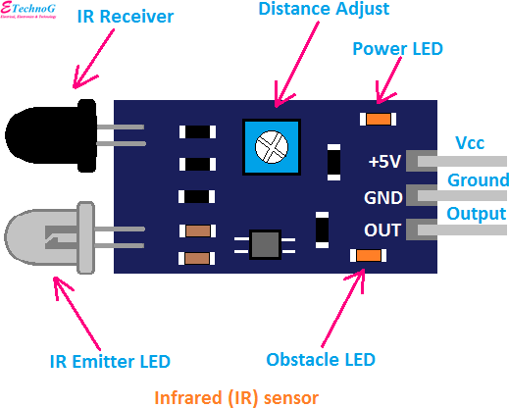
IR Sensor module has great adaptive capability of the ambient light, having a pair of infrared transmitter and the receiver tube, the infrared emitting tube to emit a certain frequency, encounters an obstacle detection direction (reflecting surface), infrared reflected back to the receiver tube receiving, after a comparator circuit processing, the green LED lights up, while the signal output will output digital signal (a low-level signal), through the potentiometer knob to adjust the detection distance, the effective distance range 2 ~ 10cm working voltage of 3.3V-5V. The detection range of the sensor can be adjusted by the potentiometer, with little interference, easy to assemble, easy to use features, can be widely used robot obstacle avoidance, obstacle avoidance car assembly line count and black-and-white line tracking and many other occasions.
IR Sensor Module Features
5VDC Operating voltage
I/O pins are 5V and 3.3V compliant Range: Up to 20cm
Adjustable Sensing range Built-in Ambient Light Sensor 20mA supply current Mounting hole

3.SG90 Servo motor

Servos are controlled by sending an electrical pulse of variable width, or pulse width modulation (PWM), through the control wire. There is a minimum pulse, a maximum pulse, and a repetition rate. A servo motor can usually only turn 90° in either direction for a total of180° movement.
TowerPro SG-90 Features
Operating Voltage is +5V typically Torque: 2.5kg/cm
Operating speed is 0.1s/60° Gear Type: Plastic
Rotation : 0°-180° Weight of motor : 9gm

Schematic

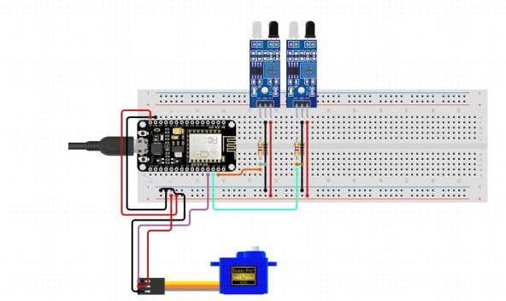

Working Model
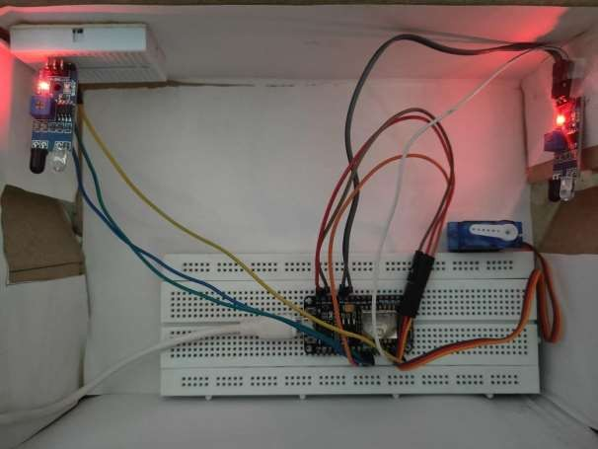
- In this prototype two IR sensors are used one is for entry detection and the other one for exit detection.
- If a person moves across the entry sensor, then the in value will be incremented. Similarly, if a person moves across the exit sensor, then the out value will be incremented.
- The Controller will compute the difference and then will store value in the total variable i.e. total = in – out
- The in value, out value and total number of people inside will be shown in the BlynkIOT website and mobile app as well.
- If the number of people increase beyond the limit (the limit is currently set to 10) then the Servo motor will rotate and close the door.

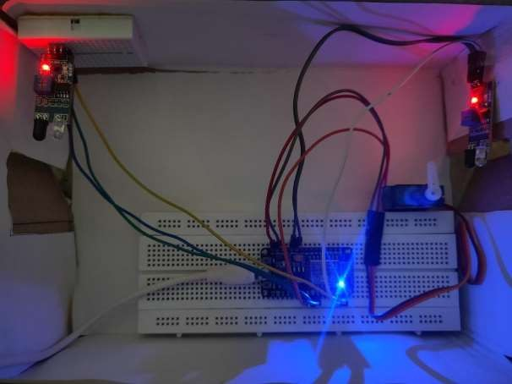

- After that if the number of people becomes less than the specified range then door Servo motor will rotate to open the door.
- Using The Blynk IOT platform we can control the range of the people which enables us to control the number of people in different situations very easily.

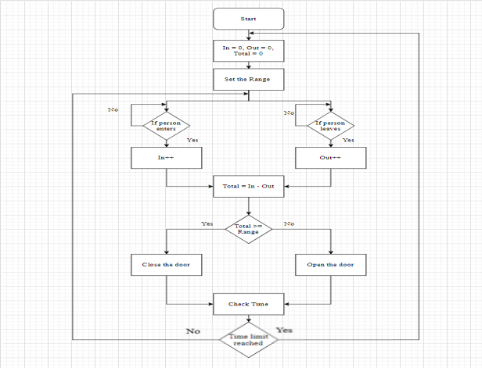
Flow Chart: -

Communication System
Through wi-fi it can be connect to the mobile BlynkIot application and nodemcu has wi-fi in the controller.

User Interface-

Web Dashboard of Blynk IOT:
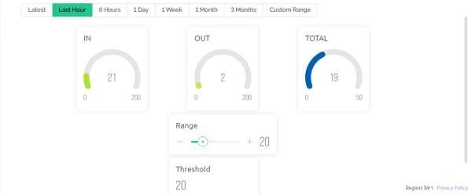

Mobile App of Blynk IOT:

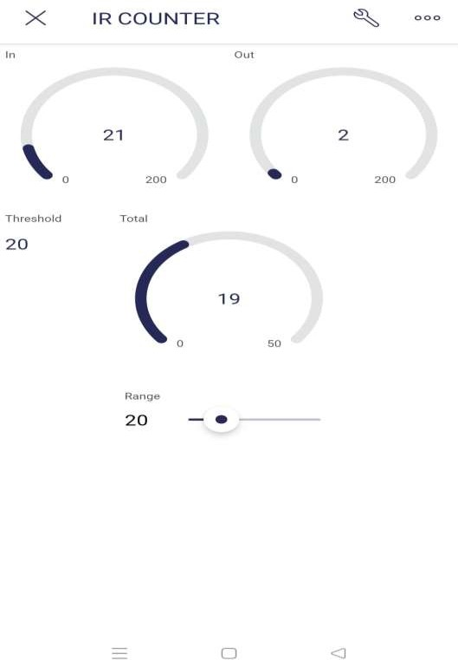

Existing product on internet which can be uses in real-time.

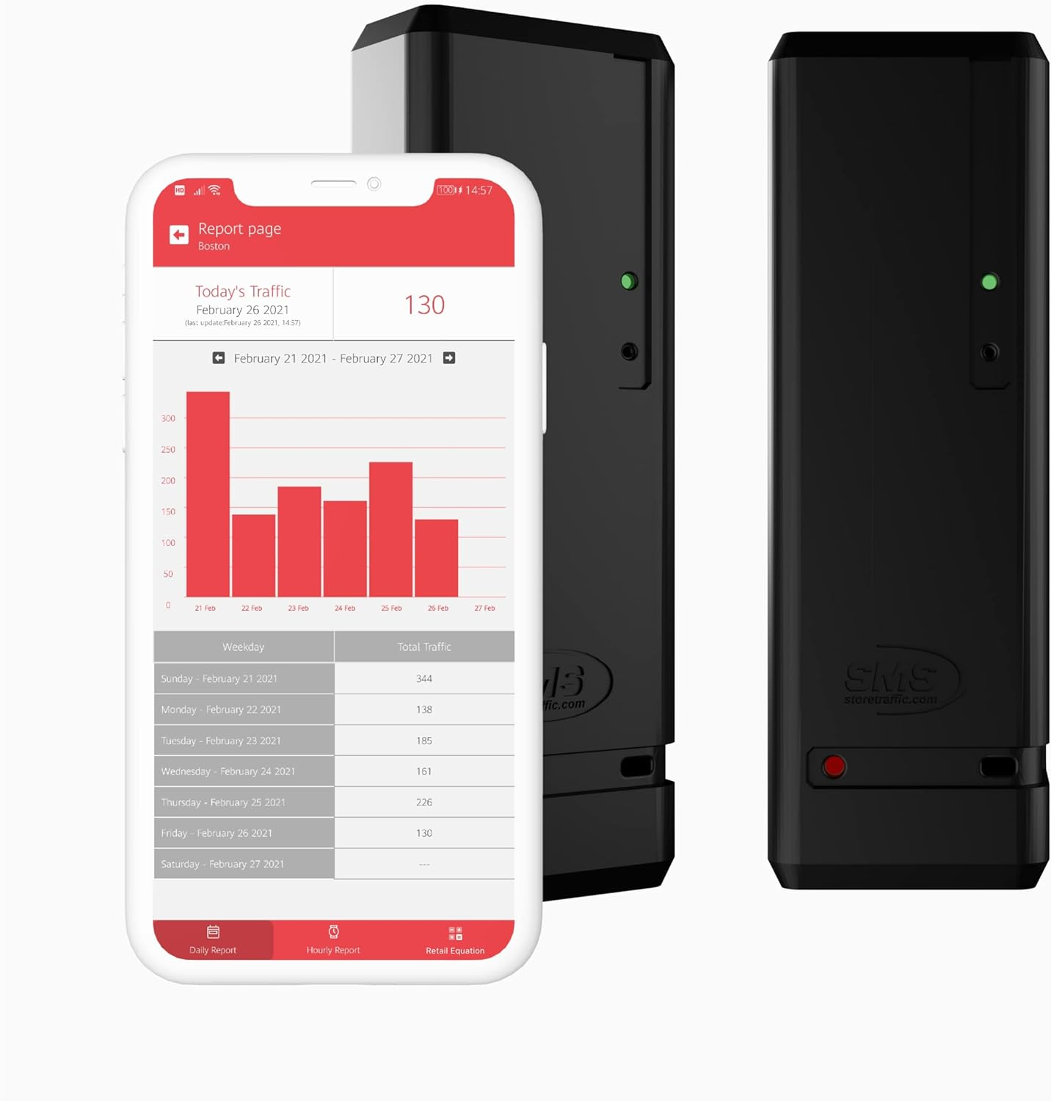

System specification –
- AUTOMATED PEOPLE COUNTER: Get hourly updates on foot traffic in and out on your phone, tablet, or computer by counting adults alone or adults and children. Supermarkets, shopping centers, libraries, museums, real estate, and retail all have faith in us. Professional people counting equipment, the PEARL Smart People counter has special features like cloud-connected apps and Wi-Fi connectivity that you won't find anywhere else.
- HIGHER OUTCOMES AT A CHEAPER COST: Away with expensive door sensors and clicker tally counters. PEARL provides insights to grow business and optimize operations (requires WiFi network and Internet access). readily establishes a WiFi connection. Operates in entryways up to 15 feet broad (or 7 feet in direct sunlight).

- CENTRALIZED DATA: The only affordable, intelligent door people counter available is PEARL. It is completely wireless, requires no setup fees, runs on regular AA batteries, and includes a free cloud-connected iOS and Android app that allows you to view the last four weeks' worth of hourly and daily foot traffic data. Plans and full-suite analytics software that are accessible, offering unrestricted historical traffic and advanced features.

- The PEARL People Counter works as a pair of two sensors. Together, they create a dual invisible beam signal that captures footfall numbers precisely in both directions

Conclusion
- To sum up, bi-directional visitor counters are essential for a variety of contemporary uses, such as public transportation hubs, retail establishments, and event spaces. They are crucial for establishing environments that are safer, more effective, and more pleasurable for everyone because of their capacity to offer real-time insights and enable proactive management.

